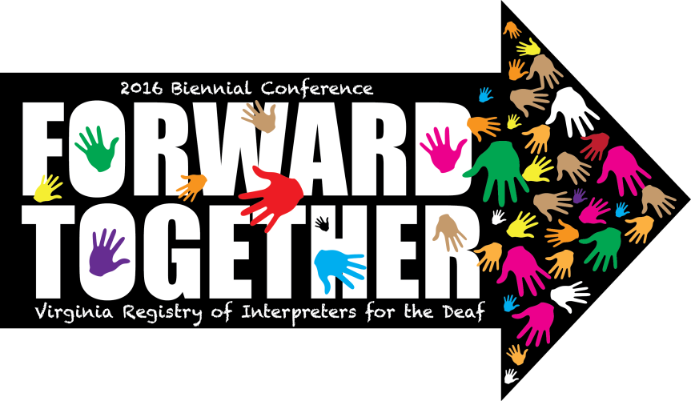

We have a pre-conference opportunity and request for you. Presenter Hilary Mayhew is offering a free online assessment and professional development tool for 20 VRID conference attendees ($11-18 value) in conjunction with her workshop on Saturday 6/25 from 9a-12p. Anyone can attend her workshop, but we hope some of you may have an extra incentive to do so!

Please read the Q&A below and then fill out this form ASAP if you would like to participate. If you sign up, you are committing to take a 15-25 minute online assessment by June 20.

Opportunity:
Hilary is offering the Intercultural Development Inventory (IDI), which is an online assessment and professional development tool for understanding and developing “intercultural competence.” Extensive research goes into making sure the IDI is valid and reliable across cultures and that the IDI has Qualified Administrators. This work is funded through the assessment fees. Hilary is donating her honorarium so the first 20 people to sign up can receive the assessment for free.

Workshop description:
Diversity and intercultural communication are an integral part of our profession. Navigating these differences is also complex, and most of us receive little instruction about it! If you’ve felt at a loss for supportive, evidence-based professional development resources in this area, please join us for this unique workshop. (And if you are a mentor, educator/trainer, or organizational leader, definitely don’t miss it!) Interpreters are seeing both possibilities and pitfalls emerge in our field as we grapple with complex issues of cultural identity and social justice in interpreting. We’re not alone in this; we can and should learn from similar professions how to effectively navigate these issues together. Research shows that a) people develop common skillsets and mindsets when interacting with cultural difference (including issues of social equity or social justice); and b) when we know more about ourselves and others, we can improve the skillsets that match our goals. The Intercultural Development Inventory (IDI) is an extensively-researched assessment and professional development tool, now available to conference attendees. The IDI allows us to see an individual’s or group’s progression along a continuum of cross-cultural competence. During the workshop, we’ll review the IDI theory and how it applies to interpreting. We’ll also review the anonymous Group Profile results of VRID attendees (or similar groups of interpreters), and the strategies that the results indicate will be most effective for working together. (More info: https://idiinventory.com/products/12-reasons-for-using-the-idi).

Why should I take the IDI? Is it just another personality test?
The IDI helps people better understand themselves and others, set realistic goals, select or plan appropriate professional development activities, and find the resources most relevant to them and their colleagues. The IDI is not a personality test. It’s currently the only theory-based, developmental assessment of intercultural competence, which measures both skillsets and mindsets. It’s meant to facilitate healthy conversations and actions directed toward growth and development across diverse communities.

Also, it’s free for the first 20 participants!

What if I’m not sure yet which workshop I want to take at the conference? Can I still take the assessment?
Yes! We’d like at least 20 participants to take the IDI from VRID. Ideally, you’ll come hear about the IDI theory and results in person, but if you can’t, we have options. If you’re choose a different workshop but want to see your results, let Hilary know anytime and she can send you more information for learning about the IDI theory. Then you can schedule a time to meet with her about your individual results.

Ok, I want to take the IDI! What do I need to do now?
- Please fill out this form ASAP
- Hilary will order an assessment for you, and email you the instructions to access it. When you receive the email with your username and password, click the link, and begin the assessment!
- The assessment takes 15-25 minutes. Complete the assessment by June 20, 2016.

When do we get our results and what is a Group Profile?
You’ll receive the VRID IDI Group Profile at the workshop. This is an anonymized, aggregated Group Profile of all VRID members/local interpreters who have taken the IDI. **Your individual results are never shared with anyone but you.**
Many organizations use the Group Profile to help them better understand the strengths, needs, and dynamics in their field. It also helps us understand the IDI theory when we can tie it to our own context! Participants often find the Group Profile results really useful on their own.

Can I get my individual results?
Yes, after the workshop. If you’d like, you can receive an Individual Profile and Individual Development Plan with your assessment (no additional fee). These are not shared during the workshop though, as the focus is on understanding the IDI theory and how it applies to us as a group.

What are the Individual Profile and Individual Development Plan?
The Individual Profile includes your confidential assessment results. The Individualized Development Plan is a template you can use to further your intercultural competency development goals, and the suggested activities are customized to your results.

Hilary will be available for individual 30-45 minute meetings with individuals who want to receive, review, and ask questions about their results. We can meet during the conference, or anytime in the 2 weeks after the workshop, online or in person.

Why a separate meeting?
IDI results are meant to be a professional development tool that you can understand, apply, and benefit from.
Hilary's IDI Qualified Administrator agreement requires she only share individual results during a debriefing meeting where she can answer your questions, discuss the results confidentially, and discuss ideas for applying the IDI to your work in a way that supports your goals.

I have another question.
Feel free to email Hilary anytime! Hilary.mayhew@gallaudet.edu

